Machine Learning Lab

Numpy:
NumPy is a Python library used for:
- Working with large arrays and matrices
- Performing mathematical and statistical operations
- Linear algebra
- Random number generation
- Scientific computing
- Data analysis (used with Pandas, SciPy, and Matplotlib)
Eg: 1D Array:
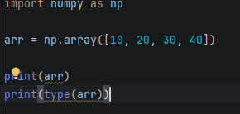
2:2D Array
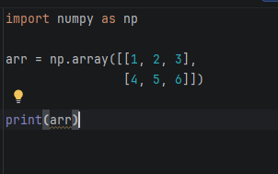
3:Creating special array:
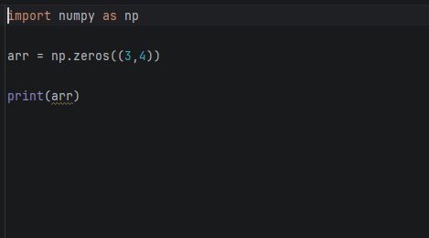

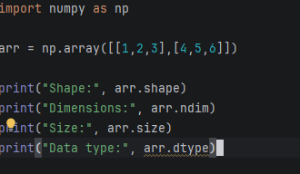
5:Array indexing
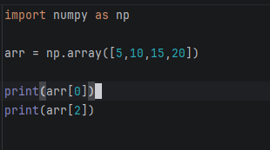
6:Maths Operation
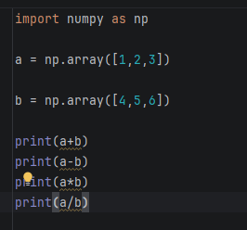
Pandas
Pandas is an open-source Python library used for data analysis and data manipulation. It provides powerful data structures like Series (1-dimensional) and DataFrame (2-dimensional) to efficiently work with structured data.

Features of Pandas
Read and write CSV, Excel, JSON, SQL files
Handle missing data
Filter and sort data
Merge and join datasets
Perform statistical analysis
Group and summarize data
Clean and transform data

Eg:
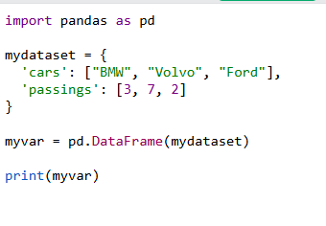
Matplotlib
Matplotlib is a popular Python library used for data visualization. It helps create graphs, charts, and plots to represent data visually.

It is widely used in:

Data Science
Machine Learning
Statistics
Scientific Research
Business Analytics

The most commonly used module is matplotlib.pyplot, imported as plt.

